The Torch

Quebec Region
Volume 6 Number 1 March 2007

Word from Phil Doddridge, veterans spokesman
It seems that my first thoughts are about my comrades and their welfare.
I have to report on the passing of two stalwarts in the Quebec-Maritime region since our last newsletter.
Reggie Law, who spent his last days in the Veterans’ wing of the Campbellton Hospital,has left us. Reg, as we all know, was a tower of strength and a mentor and help to his comrades and the widows in the Campbellton area.
He will be greatly missed, and we extend condolences to Eileen, who was with him to the end.
Because of a communication glitch I missed his funeral ceremony, a fact that I regret and one that will not cease to haunt me.

Richard (Dick ) Keays, a good friend and a long time supporter of the Hong Kong Veterans’ Association, died in the Campbellton Hospital.
Bob Barter and I were able to attend his funeral service, an impressive ceremony at which his sons delivered the eulogy and sang as part of the celebration of Dick’s long and productive life.


HKVCA Administration
Philip Doddridge
HKVA, National President
Veterans’ Spokesman
Lucette M. Muir
Quebec Regional Director
Allan Marshall
Treasurer
Debbie Batley-Everett
Secretary
Marcel Mondou
Deputy Director
Membership Chairman
Renay Perrier
Deputy Director
- - -
18 rue Barre
Granby, QC
J2H 2E6
Tel.: 450-375-7439
It will be remembered that Dick was present at Wong Nei Chong Gap as an assistant to Brigadier Lawson when the Japanese attacked. At a ceremony at Wong Nei Chong in 2000, Dick was unable to control his emotions, remembering the events of that episode in 1941.

We also hear of the passing of Dr. Ken Cambon, who was one of the younger Hong Kong Veterans.
Ken was in the Signal Platoon of the Royal Rifles.
After coming home in 1945, he went back to school and became a doctor. He moved to British Columbia, where he served in his profession until illness ended his active career.
Ken authored the book, “Guest of Hirohito”. It is still available. It is a worthwhile read.

Henry Lyons is still with us. Henry had a bad bout with a skin ailment and spent some time in the Centre Hospitalier Baie des Chaleurs in Maria.
I was able to get to see him a few times. He is now at home, and when I spoke to him yesterday, he seemed strong and in good spirits.
It will be remembered that he and Isabel lost their youngest son, Kenneth, just a few months ago. Our sympathy is sincerely extended to them.

Arnold Ross has suffered a set-back, having to be admitted to the hospital. He is now in the nursing home, Residence St-Joseph in Maria, just a few miles from where I live.
I have been to see him, and he is resting comfortably, but at his age of 89, he is unlikely to return to his usual robust self.
It is sad to see a man like Arnold incapacitated as he is, when he led such an active and positive life. He has won every award that his peers and the Town of New Richmond have to offer. He once said to me that if he got another award, he would have to build another wall in his house to hang it on!!

MEMORIAL WALL
You have no doubt heard that there is a movement afoot to push for the erection of a Memorial Wall to list the names of Hong Kong Veterans.
The wall, we hope, will be installed at a site in Ottawa, near the National War Museum.
If you wish to donate, and are computer savvy, go to the home page of the website, hkvca.ca. It will explain the purpose of the memorial and show you how to donate.
If you wish to use Canada Post to contribute, you can send your contribution to Barry Mitchell, 22 Tunis Bay, Winnipeg, MB, R3T 2X1.
Your donation will serve two purposes; it will honour the memory of a departed comrade, friend or relative, and at the same time it will contribute to the erection of a memorial that will honour the memory of all Hong Kong Veterans. In addition, you will receive an income tax credit.
Best of all, it will give you a warm feeling to know that you are doing your bit to remember.

AND FINALLY
Thank you, comrades and friends for getting this far in my rambling account of the thoughts that occupy my sometimes vacant mind. I wish you all the best of everything and hope for your good health and happiness until we meet again.
Be good to each other, and may God Bless.
Philip

Word from Quebec Regional Director Lucette M.Muir
Greetings all.
2007 another year, my goodness how time goes by.
The sun is warming up, the snow is melting or at least it will not be lasting much longer. Here in our area, farmers are fast at work for the maple syrup season. The sweet smell is in the air.
Since our last newsletter some members of your executive took a bit of personal time. Unfortunately we had sad moments with the passing of more of our Comrades (reported later). Due to weather and time I hope that the families will forgive us for not attending these ceremonies.
Plans are in the works for our next HKVCA Executive meeting followed by our Joint-Executive meeting. As usual year end reports will be given, projects will be reviewed, next reunion, all in all the general administration of your Association. Items to be discussed with members of the Board of Directors at the upcoming Convention will also be on the table.
At a banquet on January 21st Llewllyn “Bill” Doull of BC was recognised by members of his Royal Canadian Legion Branch as a Hong Kong Veteran and was also presented with his 60 Year Pin as an active legion member. Congratulations Bill.
Flash and Jessie Clayton are still hard people to keep up with – so busy. Flash will be inducted in the Canadian Veteran Hall of Valour on May 26 as will Lionel Speller. Congratulations.
Memorial Wall
I will not repeat Phil’s report on this project. The erection of a Memorial Wall with all the names of Hong Kong Veterans will honour their memory. If you feel you can do your bit to keep the memory alive and the project going, please do so, it will be worth it in your heart.
As your Regional Director, I would like to ask our Regular members (paying members) please try helping us, as well as your National Membership chairperson by taking care of your annual dues as soon as possible. Dues remain payable early to be effective January 1st to December 31st of the current year. I would sure hate to hear that someone did not receive their Convention kits, newsletters or other mailings due to a late payment of your membership. Marcel and Allan, your Regional Treasurer will love you all even more for being prompt with your dues as Allan has to forward part of this share to the National to keep their membership records of straight.
If you have a problem or questions, please do not hesitate to contact Marcel or I. We would sure like to keep you all interested and active as members. We need to keep the Memory Alive.
Veterans and Widows are lifetime members of the HKVCA.
Your executive committee would like to take this opportunity to wish you all a Happy St. Patrick and a Happy Easter.
Lucette

Last Post
At this time we are sad to report the passing of more of our comrades. Some of these names may have been mentioned elsewhere, but in the interest of keeping the record straight, they are mentioned here. In no particular order: Reginald Law RRC, Jean Pierre Lalime RRC, Clarence Stewart WG, Richard “Dick” Keays RRC, Dr. Kenneth Cambon RRC.
Widows: Marjorie Lyons widow of Arthur Lyons Wg
Regular (HKVCA): Kenneth Lyons son of Henry Lyons RRC.
They shall grow not old; Age shall not weary them nor the years condemn. At the going down of the sun and in the morning.
WE WILL REMEMBER THEM!
Our thoughts and prayers go out to all families in this time of great sorrow.
Sick Parade
Our thoughts go out to: Henry Lyons in hospital with a severe skin ailment, Arnold Ross is at this time in St.Joseph’s Nursing Home, 491 boul. Perron Ouest, Maria, QC G0C 1Y0. John Levitt has been diagnosed with lung infection and is very frail and weak.
Frank Brown recently had his left leg amputated in the Chilliwack BC hospital. Well wishes can be sent in care of his daughter: Frank Brown c/o Jackie Grosart #85 – 6449 Blackwood Lane, Chilliwack BC V2R 5X5.
Fred Mason doing very well and back to his activities.
Other veterans and widows have been under the weather with different ailments and possibly more that we did not hear about.
A friendly note or call to these people is very “good for the moral”.
Our thoughts and prayers go out to all our sick.
Take care,
Humour
The Silent Treatment
A man and his wife were having some problems at home and were giving each other the silent treatment. Suddenly, the man realized that the next day, he would need his wife to wake him at 5:00 AM for an early morning business flight.
Not wanting to be the first to break the silence (and LOSE), he wrote on a piece of paper, “Please wake me at 5:00 AM.” He left it where he knew she would find it. The next morning, the man woke up, only to discover it was 9:00AM and he had missed his flight. Furious, he was about to go and see why his wife hadn’t wakened him, when he noticed a piece of paper by the bed. The paper said, “It is 5:00 AM. Wake up.”
Happy Birthday
April: Debbie Batley Everett, Jean Paul Dallain, Phil Doddridge, Edwina Doddridge, Marcienne Lalime, Henry Lyons, Catherine Marshall, Fred Mason.
May: S. Martin Banfill, Jessie Clayton, Geraldine Cunningham, Una Lapalme.
June: Graham Boudreau, Barbara Hardy, Eva Hunt, Bill Kellas, Ralph Maclean.
Wedding Anniversary
April: Claire and Bill Doull will celebrate their 51st anniversary.
Happy Birthday
Happy Anniversary and
Best Wishes to all
(If we have your birthday month, all the HK Family would know of your special day and even send you their personal wishes).
Correspondence
In no particular order, received correspondence or calls from: Irene Dallain, Alfred and Christina Babin and they are doing well considering their aches and pains, Veronica Hunt with also news of her Mom Aline Hunt who is doing well considering her heart problems, Ilene Law thanking all Veterans, family and friends who attended Reggie’s funeral on January 3rd .
Donations In no particular order: Randolph Benwell, Rita Leblanc, Celia Smith in memory of Goldie Ramier, Martin Banfill, Marion Bisson, Alfred Babin, Bill Doull, Joyce Aitkens, Irene Dallain in memory of Dick Keays, Austin Batley, John Roussel.
Many Thanks to all of you for your participation for the welfare of your Association.
Membership
Greetings to all.
I again am here to encourage you to keep up your membership by sending us your $ 15.00 each current calendar year, effective January.
Your 2007 cards and stickers are waiting for you. Why wait until later to be a member in good standing? You might miss out on something great. This condition will affect continuing to receive The Torch as well as the National Newsletter.
(HK veterans and widows are Lifetime Members).
If you are moving in the near future or if you have been blessed by Canada Post making their changes or City re-organizations (without you moving from your home) PLEASE DO NOT FORGET TO LET ME KNOW your new address (changes in these cases are not made automatically) as you might experience delays or simply may not receive the delivery of your next newsletters, correspondence etc.
Correction In the December 2006 issue of the Torch our new member Michael Brunet was welcomed as the grandson of Lucien Brunet and it should have read SON. Sorry for the confusion.
If you have any questions on membership, feel free to call or write to our Granby address or by e-mail at mondoumarcel@videotron.caThank you all for your support and great interest in our association. Happy Easter to all.
Marcel
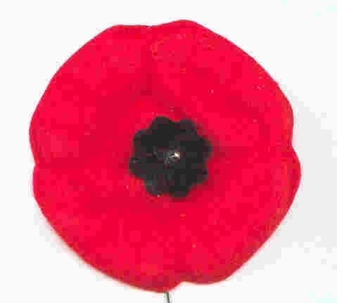
Take the time to remember!
“THANK A VETERAN!”
Humour
An Irish Candle Story
Mrs. Donovan was walking down O’Connell Street in Dublin when she met up with Father Flaherty. The Father said, “Top o’the mornin’ to ye! Aren’t ye Mrs. Donovan, and didn’t I marry ye and yer husband two years ago?” She replied, “Aye, that ye did, Father.” The Father asked, “And be there any wee little ones yet?”! She replied “No Father”
The Father said, “Well now, I’m going to Rome next week and I’ll light a candle for ye and yer husband.”
Some years later they met again. The Father asked “Well now, Mrs. Donovan, how are ye these days?” She replied, “Oh, very well, Father!” The Father asked, “And tell me, have ye any wee ones yet?” She replied,
“Oh yes, Father! Three sets of twins and 4 singles…10 in all!” The Father said, “That’s wonderful! How is yer loving husband doing? She replied, “E’s gone to Rome to blow out yer candle!”
Convention 2007
The Alberta/Saskatchewan Region of the HKVCA has graciously accepted to host the next National HKVCA Convention on August 15-19 2007 in Calgary. Things will take place at the Hyatt Regency Hotel, 700 Center St. S., Calgary, AB.
Invitation kits should be in the mail in March 2007.
See you then.
QuebecReunion 2008 is still a long time from now but we are working on something. Will have more news as time advances.
Humour The wise old Mother Superior from county Tipperary was dying. The nuns gathered around her bed trying to make her comfortable. They gave her some warm milk to drink, but she refused it. One nun took the glass back to the kitchen. Remembering a bottle of Irish whiskey received as a gift the previous Christmas, she opened it and poured a generous amount into the warm milk. Back at Mother Superior’s bed, she held the glass to her lips. Mother Superior drank a little, then a little more. Before they knew it, she had drunk the whole glass down to the last drop.
“Mother,” the nuns pleaded, “Please give us some wisdom before you die.”
She raised herself up in bed with a pious look on her face and said,
“Don’t sell that cow!”
Book Corner
The Royal Rifles of Canada in Hong Kong by Grant Garneau is still available from your Quebec Region. It is for sale at the cost of $ 50.00 per copy, including shipping and handling. Just contact Lucette with your order and cheque.
Other books are also available through your National Address.
Nominal Roll
Plastic-coated copies 12” x 19” of the Nominal Roll of the Royal Rifles in Hong Kong are available for sale at the cost of $ 10.00 including postage. Make your cheque payable to HKVCA,QC for the number of copies required and mail to HKVCA, 18 Barre, Granby, QC, J2H 2E6.
Maple Leaf Broach

The Maple Leaf Broach is available through your regional address for $ 25.00 including handling and shipping costs.
It is the same size (1”x1 ½”) as the originals but it is silver in colour only with the regular coloured HK logo.
Please make your cheque x number of broaches, payable to HKVCA QC and send to your Quebec address.
Quebec Region Polo
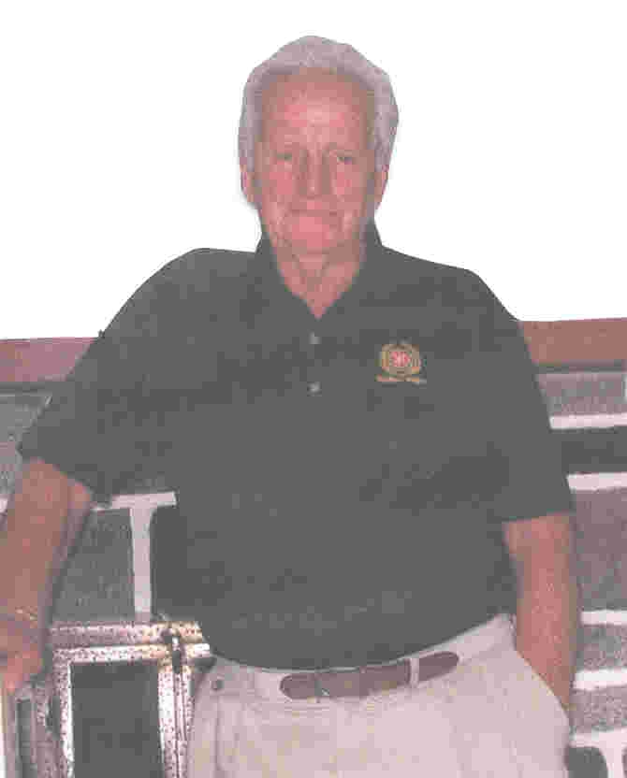
Quebec Region has designed a new polo shirt. It was worn with beige slacks by all executive members for the first time during our recent Reunion.
It is Hong Kong green in color, a light knit, short sleeves with the HKVCA logo and Quebec Region embroidered in it’s original colours (no pocket).
It was quite a hit during the Reunion and we decided to offer it to all members. It is available in sizes S, M, L, XL, XXL at the cost of $ 25.00 including shipping. Mail your cheque to the Granby address and payable to HKVCA QC.
NOTE: S and XXL in limited quantity have been added.
Grand Kids are Great
When my grandson asked me how old I was, I teasingly replied, “I’m not sure.” “Look in your underwear, Grandma,” he advised. “Mine says I’m four to six.”
--
A second grader came home from school and said to her grandmother, “Grandma, guess what? We learned how to make babies today.” The grandmother, more than a little surprised, tried to keep her cool. “That’s interesting,” she said, “How do you make babies?” “It’s simple,” replied the girl. “You just change ‘Y’ to ‘i’ and add ‘es’.”
By Kids
Whom to marry –You got to find somebody who likes the same stuff. Like, if you like sports, she should like it that you like sports, and she should keep the chips and dip coming. Alan, age 10.
The right age to marry – 23 is the best age because you know the person FOREVER by then. Camille, age 10.
What do most people do on a date? – Dates are for having fun, and people should use them to get to know each other. Even boys have something to say if you listen long enough. Lynnette, age 8. (isn’t she a treasure)
- On the first date, they just tell each other lies and that usually gets them interested enough to go for a second date. Martin, age 10.
When is it OK to kiss someone? – The law says you have to be 18, so I wouldn’t want to mess with that. Curt, age 7.
How would the world be different if people didn’t get married? – There sure would be a lot of kids to explain, wouldn’t there? Kevin, age 8.

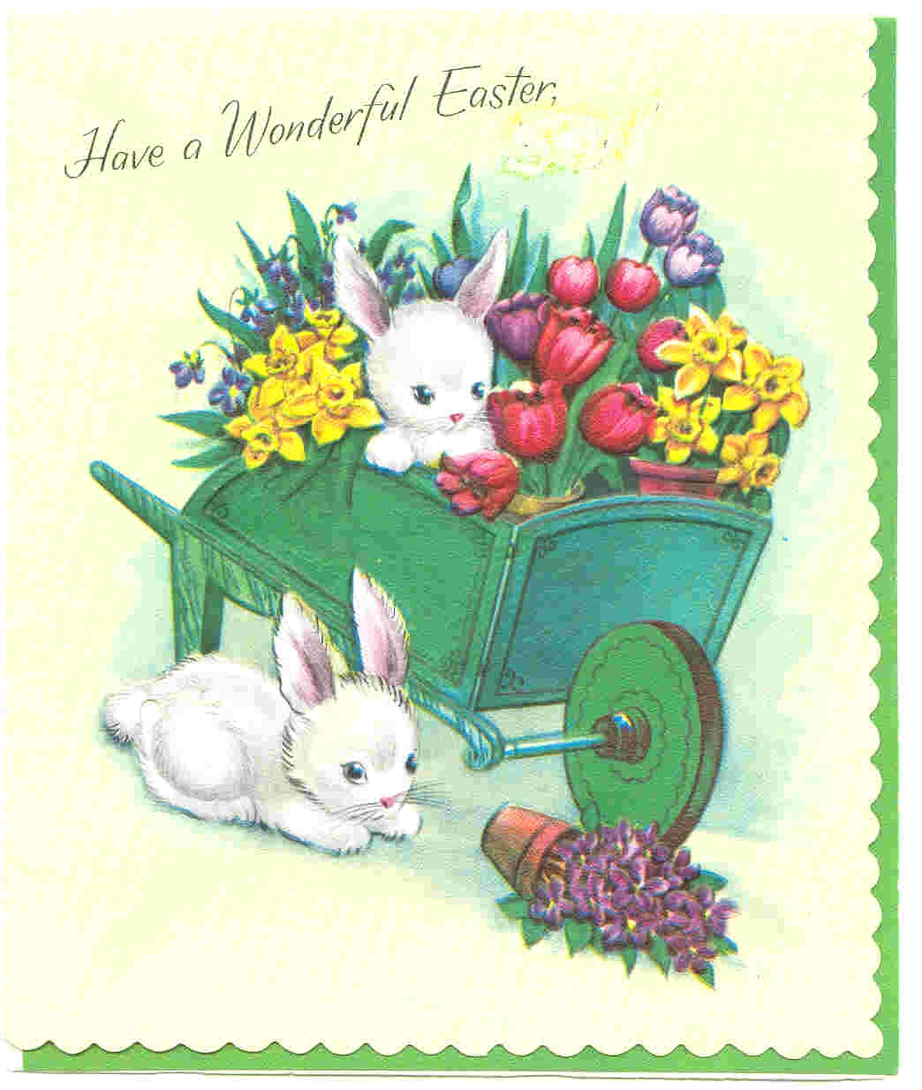
Happy
Easter
To
You
And
Yours
Your Executive

That is it for this time.
Take care,
Till next time – June 2007.
Lucette

