The Torch

Quebec Region
Volume 5 Number 4 December 2006

Word from Phil Doddridge, veterans spokesman
VETERANS
I have been in touch recently with a number of HK Veterans. We are a diminishing lot, and it is ever so comforting to contact those of us who are left.
Yesterday I talked with Pierre Delarosbil, who lives in Pasbebiac, Quebec, just thirty miles down the road from me. He has not been active in the Association, and as far as I can remember, has never attended a reunion. He is 86 years old and except for the aches and pains that we all have, is in reasonably good health.
I visited Bob Olscamp at his residence in Atholville, NB. He has a nice apartment and is well looked after by the attendants.
I speak with Henry Lyons often. Henry is motoring along, with the usual aches and pains.

HKVCA Administration
Philip Doddridge
HKVA, National President
Veterans’ Spokesman
Lucette M. Muir
Quebec Regional Director
Allan Marshall
Treasurer
Debbie Batley-Everett
Secretary
Marcel Mondou
Deputy Director
Membership Chairman
Renay Perrier
Deputy Director
- - -
18 rue Barre
Granby, QC
J2H 2E6
Tel.: 450-375-7439
I see Bob Barter often, as he
lives only a few miles from me.

Bob and I drove to Quebec for the burial of the ashes of Albert and Monique Russell.
The funeral service was very impressive, with members of the family taking part in the ceremony.
We stayed with Betty Firth, who fed us and drove us to the funeral and to the reception afterwards.
Lucette, Marcel, and Allan Marshall also attended.
Bob and I were too wiped out to attend the funeral of Ossie Clark two days later, which meant that we would have had to turn around and drive back 800 klicks. Now I wish I had persevered and put out the extra effort. I hope that Hope and Sue will forgive me for not attending. We go back a long way, since Hope was a little girl in the school where I was a principal for nine years. Ossie and I also had a close friendship.
What is done is done.
ROSES IN DECEMBER
I read the weekly book reviews, and when a title catches my eye, I send for the book at one of the on line book stores.
Recently I received a book titled, “Roses in December” by David Stanford.
It is a story about his grandfather who was in the Royal Scots in Hong Hong. He died when the Lisbon Maru was torpedoed by the USS Grouper when the Japs were transporting POWs from Hong Kong to Japan.
A quotation in the front fly leaf reads: “God gave us memory so that we might have roses in December”.
It gives a different perspective of the Battle and what followed. Stanford’s view is that the Royal Scots and the Middlesex Regiments were no better prepared than we were, having spent the previous years as garrison troops in India and Hong Kong.
As an appendix, it includes the complete Maltby Report to the British Parliament.

CANADA UNDER ATTACK
I have been invited to attend the official opening of a new exhibition at the War Museum in Ottawa. It is called, “Canada Under Attack” depicting the war in the Gulf of St. Lawrence. I will regretfully decline, since it is planned for December 21, and these old bones are finding it harder and harder to travel, especially in the winter. I say regretfully, because it is partly created by Jean-Marie Fallu, curator of the Musee de la Gaspesie, with whom I am acquainted and who has given us help and advice in the setting up of our Military Museum in New Richmond.
So be it.

CORRECTION
Geoffrey Knowles wrote to me about a story I told in the September 2006 issue of the Torch. I had quoted a radio report that the Canadian who had signed the Instrument of Surrender with the Japanese, had done so on the wrong line. Geoff took the trouble to send me a copy of the official document showing that Colonel Cosgrove had indeed signed in the proper space. So much for radio reporting. Anything for a story?
Geoff also stated that his presence as a member was not fully appreciated and that he wished to resign. I replied that his membership was of value and that his presence at reunions added colour to the event.

AND FINALLY
Christmas always finds me with mixed emotions, but I’ll take this opportunity to wish one and all the best of everything for Christmas and the best of good health and good fortune in 2007.
2007? Where has the time gone
That’s all for this time.

Be good to each other, and may God Bless.

Philip

Word from Quebec Regional Director Lucette M.Muir
2006 an other year has come and is fast coming to an end.
Since our last newsletter, on October 21st Allan Marshall, Marcel and I motored to Quebec City to attend the burial of the ashes and the celebration of life for Albert and Monique Russell. The funeral service at St Michael’s Church was very impressive, with children John, Robert, Louise, Lillian their spouses, grand-children, great-grand-children,
members of both families, Phil Doddridge and Bob Barter HK Comrades as well as many local veterans and friends. Members of the family participated, ‘Amazing Grace’ sung by Roxanne Cote-Russell, 1st Reading read by Kate Russell, 2nd Reading by Louise Dorion-Voyer, 3rd Reading by Susan Gauvin taking part in the ceremony. The Eulogy was given by Robert and John Russell.
At the graveside the air was cool with a cloudy sky. Prayers and blessings were said and while the bugler played The Last Post, Silence and the Reveille a bright ray of warm sunshine pierced through the clouds for Monique and Albert
Together Always

I was in contact with Clemence and Sue Clark re Oswald Clark’s health and circumstances following. Unfortunately Marcel and I were not able to attend his funeral October 25 as we were on our way to Vietnam. We hope that Hope and Sue will forgive us for not attending. HK Vet Eric Batley, Debbie Batley, Allan and Cathy Marshall, Alma Wood, family members, friends as well as many Veterans from Bury, Sherbrooke and area attended the service at St Paul’s Church in Bury, QC.
The Eulogy was given by a lifelong friend Robert “Bob” Plumkett. Ozzie cared deeply for his family and was a family man, a soldier, a tradesman, an entrepreneur, and a pioneer. Ozzie was one of the most active members of the Royal Canadian Legion and had deep concern for his fellow comrades-in-arms. In spite of the extreme hardship suffered during his younger life, the prison camps, he considered himself to be luckier than many and he was always quick to help a fellow veteran in need. Ozzie wanted all to celebrate his life in the manner of an Irish wake, so in that spirit Bob offered a Celtic prayer and in closing to Ozzie he said in the Cantonese Chinese dialect of Hong Kong “fangaau ngohge hou pahngyouh”
“Sleep well, my good friend”

For November 11th yours truly deposited a wreath in memory of all Hong Kong Veterans at our local Armistice Ceremony.
In Ottawa, HK Vet Dempsey Syvret deposited a wreath in the name of all Hong Kong Veterans during Ceremonies there.

Marcel and I had a wonderful trip to Vietnam. We had, for the first time, almost 2 weeks of jet-lag to tend with. All is well now. We are in the fast track getting ready for the festive season approaching, as I am sure you all are.
That is it for this time, take care. I take this opportunity to wish each of you a Merry Christmas, Happy New Year and the Best for 2007.
PLEASE NOTE CHANGE OF ADDRESS: effective January 1, 2007 our mailing address will be: 18 rue Barre, Granby, QC, J2H 2E6.
(City of Granby + Canton of Granby = New City of Granby)
Lucette

Last Post
At this time we are sad to report the passing of more of our comrades. Some of these names may have been mentioned elsewhere, but in the interest of keeping the record straight, they are mentioned here. In no particular order: James Riddock WG, James Fiddler WG, Robert WH. Acton, Thomas Jones RRC, Clifford Matthews WG, Alfred Mills RRC, Oswald Clark RRC.
Widows: Irene Cotton widow of Joseph Leonard Cotton RRC, Mrs James Houston widow of James Houston WG, Dorothy Varley widow of Les Varley RRC, Winnifred Schofield widow of Reginald Scofield RRC, Rosa Arbour companion of Robert Olscamp, Mary Darrah widow of James Darrah RRC.
They shall grow not old; Age shall not weary them nor the years condemn. At the going down of the sun and in the morning.
WE WILL REMEMBER THEM!
Our thoughts and prayers go out to all families in this time of great sorrow.
Sick Parade
Our thoughts go out to: Marcel Ouellet is back in hospital since mid-November after a mild heart attack and is waiting for more surgery re more blockage in his legs. Kate Irving spend some time in Hospital and is now in a residence: 1645 Chemin St-Louis #117, Sillery, QC G1S 4M3.
Other veterans and widows have been under the weather with different ailments and possibly more that we did not hear about.
A friendly note or call to these people is very “good for the moral”.
Having your love ones near you has a way of helping things.
Our thoughts and prayers go out to all our sick.
Take care,
Humour
CHRISTMAS DIVORCE
Joe, in Phoenix, calls his son Mark in New York the day before Christmas and says, “I hate to ruin your day, Mark, but I have to tell you that your mother and I are divorcing; forty-five years of misery is enough.”
“Pop, what are you talking about?” Mark screams.
“We can’t stand the sight of each other any longer,” Joe explains. “We’re sick of each other, and I’m sick of talking about this, so you call your sister Sally in Chicago and tell her”.
Frantic, Mark calls Sally, who explodes on the phone. “Like heck they’re getting divorced”, she shouts, “I’ll take care of this”.
She calls Phoenix immediately, and screams at her father, “You are NOT getting divorced. Don’t do a single thing until I get there. I’m calling my brother back, and we’ll both be there tomorrow. Until then, don’t do a thing, DO YOU HEAR ME?” and hangs up.
Joe hangs up his phone and turns to his wife Nora. “OK dear, it’s all taken care of”, he says. “They’re coming for Christmas and paying their own way”.

Happy Birthday
January: Alma Wood, Darin Bennett, Bertha Barter, Michael Brunet.
February: Barbara Henderson, Freeda Malboeuf, Brinky (Doris) Murray, Annie Nolan, Yolande Ross, Larry Everett, Norma Martin, Steven H. Wilson, Marcel Mondou.
March: Laurette Daigle, Renay Perrier.
Wedding Anniversary
A quite period, it seems.
Happy Birthday
Happy Anniversary and
Best Wishes to all
(If we have your birthday month, all the HK Family would know of your special day and even send you their personal wishes).
Correspondence
In no particular order, received correspondence or calls from: Bill & Claire Doull, Renee Giard, Lillian Brunet, Jeannine Ouellet, Bonnie Vincent, Phil Doddridge, Dorothy Sauson, .
Donations
In no particular order: John Russell, Walter Gray, Alma Wood, Robert Olscamp, Eric Batley, Bill Doull, Ralph MacLean, Dorothy Sauson in Memory of Ray Sauson, Renee Giard in Memory of Bernard Castonguay.
Many Thanks to all of you for your participation for the welfare of your Association.
Membership
Greetings to all.
My responsibility is still to encourage you to keep up your membership by sending us your $ 15.00 each current calendar year, effective January.
Your 2007 cards and stickers are waiting for you. Why wait until the end of the year to be a member in good standing? March 2007 will be a cut off date. This condition will affect continuing to receive The Torch as well as the National Newsletter.
PLEASE NOTE: there will be elections at the National level of the HKVCA for next August 2007 so, to be eligible to vote then you will need to be a member in good standing. I’m confident that you will come forward very shortly.
(HK veterans and widows do not pay). Take care of that business early and you will be able to forget it and not worry about it for an other year.
If you are moving in the near future or if you have been blessed by Canada Post making their changes or City re-organizations (without you moving from your home) PLEASE DO NOT FORGET TO LET ME KNOW your new address (changes in these cases are not made automatically) as you might experience delays or simply may not receive the delivery of your next newsletters, correspondence etc.
At this time I would like to welcome new members into our Quebec HK Family, Michael Brunet, grand-son of Lillian and deceased Lucien Brunet, Steven H. Wilson, nephew of Clarence Hunt. Welcome Michael and Steven.
If you have any questions on membership, feel free to call or write to our Granby address or by e-mail at mondoumarcel@videotron.caThank you all for your support and great interest in our association. Joyeux Noel and Merry Christmas to all.
Marcel
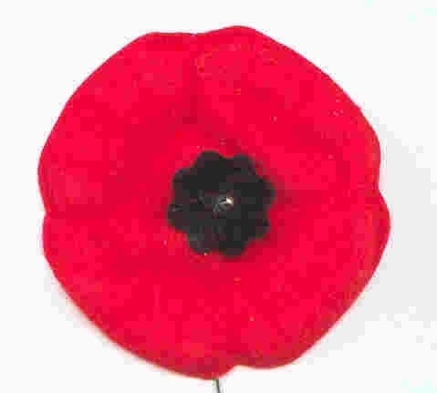
Take the time to remember!
“THANK A VETERAN!”
Humour
SOUTHERN KNOW-HOW
“Hello, is this the Sheriff’s Office?”
“Yes. What can I do for you?”
“I’m calling to report ‘bout my neighbour Virgil Smith… He’s hidin’ marijuana inside his firewood! Don’t quite know how he gets it inside them logs, but he’s hidin’ it there”.
“Thank you very much for the call, sir”.
The next day, the Sheriff’s Deputies descend on Virgil’s house. They search the shed where the firewood is kept. Using axes, they bust open every piece of wood, but find no marijuana. They sneer at Virgil and leave. Shortly, the phone rings at Virgil’s house.
“Hey, Virgil! This is Floyd… did the Sheriff come?”
“Yeah!”
“Did they chop your firewood?
“Yep!”
“Happy Birthday, buddy!”
Southerners know how to get the job done!
Convention 2007
The Alberta/Saskatchewan Region of the HKVCA has graciously accepted to host the next National HKVCA Convention on August 15-19 2007 in Calgary. Things will take place at the Hyatt Regency Hotel, 700 Center St. S., Calgary, AB.
We will keep you informed as things develop.
See you then.
Humour
AN ATHEIST’S HELL
A young lady came home from a date looking rather sad. She told her mother, “Arthur proposed to me an hour ago.”
“Then why are you so sad?” her mother asked.
“Because he also told me he was an atheist. Mom, he doesn’t even believe there’s a hell.”
Her mother replied, “Marry him anyway. Between the two of us, we’ll show him how wrong he is.”
Book Corner
The Royal Rifles of Canada in Hong Kong by Grant Garneau is still available from your Quebec Region. It is for sale at the cost of $ 50.00 per copy, including shipping and handling. Just contact Lucette with your order and cheque.
Other books are also available through your National Address.
Nominal Roll
Plastic-coated copies 12” x 19” of the Nominal Roll of the Royal Rifles in Hong Kong are available for sale at the cost of $ 10.00 including postage. Make your cheque payable to HKVCA,QC for the number of copies required and mail to HKVCA, 18 Barre, Granby, QC, J2H 2E6.
Maple Leaf Broach

The Maple Leaf Broach is available through your regional address for $ 25.00 including handling and shipping costs.
It is the same size (1”x1 ½”) as the originals but it is silver in colour only with the regular coloured HK logo.
Please make your cheque x number of broaches, payable to HKVCA QC and send to your Quebec address.
Quebec Region Polo
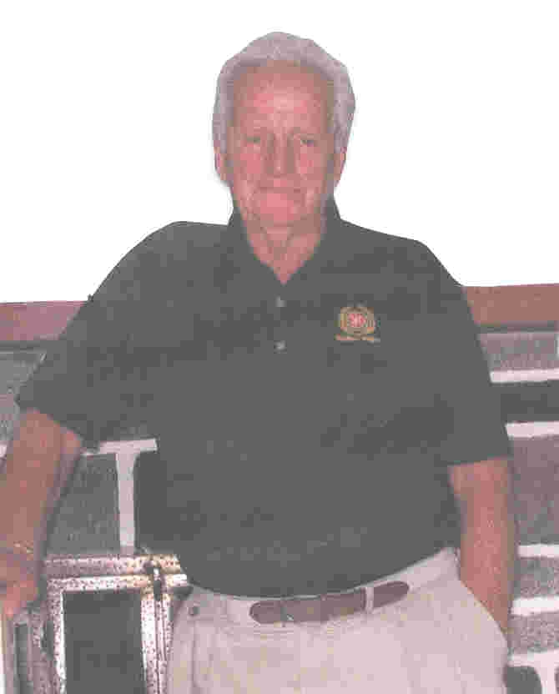
Quebec Region has designed a new polo shirt. It was worn with beige slacks by all executive members for the first time during our recent Reunion.
It is Hong Kong green in color, a light knit, short sleeves with the HKVCA logo and Quebec Region embroidered in it’s original colours (no pocket).
It was quite a hit during the Reunion and we decided to offer it to all members. It is available in sizes S, M, L, XL at the cost of $ 25.00 including shipping. Mail your cheque to the Granby address and payable to HKVCA QC.
Merry Christmas
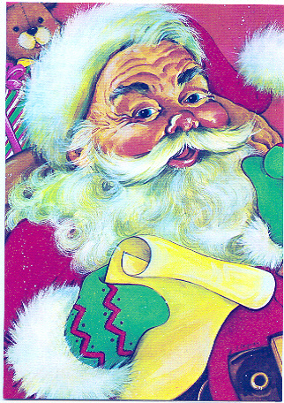
Happy New Year
Health for 2007
To You and Family
Your QC Executive
That is it for this time.
Take care,
Till next time – March 2007.
Lucette
A HERO’S THOUGHTS

