The Torch

Quebec Region
Volume 4 Number 4 December 2005

Word from Phil Doddridge, veterans spokesman

Once again it is time to pen a few words for the Torch.
There has been a lot happening since we last got together. I’ll try to recall as much as possible.
Since returning from Hong Kong and fighting jet lag for a few days, I have finally returned to normal, I think, and have been able to clear up most of the fall-out from a two-week absence.
I don’t mean to imply that I am overworked, but the e-mails and the small chores do pile up when neglected.

HONG KONG TRIP
There were six of us Hong Kong Veterans in the official party, and all of us received VIP treatment.

Thirty-eight members of the HKVCA joined us in Hong Kong. Their presence added



HKVCA Administration
Philip Doddridge
HKVA, National President
Veterans’ Spokesman
Lucette M. Muir
Quebec Regional Director
Allan Marshall
Treasurer
Debbie Batley-Everett
Secretary

Marcel Mondou
Deputy Director
Membership Chairman
- - -
18 rue Barre
Canton de Granby, QC. J2H 2E6
Tel.: 450-375-7439
immensely to the proceedings.

We had three Senators with us, Pierre-Claude Nolin, Larry Campbell, and Vivienne Poy.
When events at home prevented Minister Guarnieri from accompanying us, Senator Larry Campbell took over the leadership, and did it with gracious good humour and much respect.

There were 210 students from high schools of the Durham Region of Ontario, who had visited China before coming to Hong Kong.
The ceremony of the placing of the time capsule in the earth at Sai Wan was a very moving experience.
We later met the students and their teachers at the Canadian International School of Hong Kong. At the school I had the pleasure of meeting a teacher, Bruce MacNamara, whose family I knew from bygone days in New Richmond.

We were entertained at a dinner at the famous Jockey Club at Happy Valley Race Track.
It was at Happy Valley that the Japs had put us to work spading up the turf to plant vegetables.

Tony Banham, author of “Not the Slightest Chance” led us on a tour of the battlefields. His comments and running account of the battle told me things that I hadn’t been aware of.

On the day I left, I met Tobias Brown, an archeologist, who gave me some shell fragments and other remnants of the battle that took place on Mount Cameron. I plan to catalog them and place them on a board for display in our Museum.

On the return trip, when we were seated on the plane at Lap Chep Kok Airport, the pilot of the Cathay Pacific plane, a Canadian, came on the speaker and said: “Ladies and gentlemen, I want to inform you that we have on board, six heroes of the Battle of Hong Kong in 1941.”
Then he named each of us and said what seat each of us was sitting in.
Perfect service from that point became even better.

As a general overall comment, I would say that the trip was a total success. Truthfully, I was a little embarrassed at the hero worship.
I hope that the six of us, George MacDonell, Ed Shayler, Gerry Gerrard, Doug Rees, Flash Clayton, and I, adequately represented all of the Hong Kong Veterans. Your sacrifices and those of our departed comrades were in our thoughts at all times.

IN CONCLUSION
Time to close this rambling account of the latest pilgrimage to Hong Kong.
Before I go, I want to extend to all my best wishes for a Merry Christmas and a happy, healthy, and prosperous New Year.
May all your wishes come true.
Be good to each other and may God bless.

Philip

Word from Quebec Regional Director Lucette M.Muir
Greetings to all.
An other year is fast coming to a close. How time just seem to just run by us.
Here it is beginning to look like winter but, for other regions I see that winter is already with you.
We have returned safely from our trip to Egypt. Everything went very well in the company of a wonderful local guide and a very good group of sixteen old and new friends.
The tourists are very well protected in the country. When travelling outside the cities, our buses travelled in convoy escorted by police and military. Checkpoints at all road crossings, even in the desert. Quite an experience but well appreciated by all.
Since our last news letter, there has not been any major decisions nor plans confirmed. In mid October we held a local executive meeting to bring everyone up to date on meetings and discussions that took place during the Convention and talk about new plans and/or new ways to help our regional members.
We are all putting our thoughts and ideas on the table to bring you something new for the next reunion…
Concerning the recent Hong Kong trip, Phil gave an excellent report on the happenings We would like to say thank you to all our HK Vets and Phil who were part of the delegation of the Hong Kong Pilgrimage.
We would also like to thank Nancy Hamer Strahl from Port Perry School, Ontario, teachers, students and escorts involved with the trip to Hong Kong project for their interest in the HK Vets and working to organize such a trip for these students to learn and give them a deeper appreciation of what our Vets gave us.
Throughout the “Year of the Veteran” many ceremonies and activities took place across Canada. 2005 is coming to a close but, we wish that the year of the veteran continues and that people’s interest and appreciation for the sacrifices that were made on their behalf will always be remembered.
Remembrance Day Ceremonies we well attended by many Vets, widows, families and especially many children. In many localities, schools organized contests of different sorts, talks by Vets etc. Thanks to all who took the time to work on these remembrance projects.
Christmas is fast approaching a time to rejoice, eat and be merry for many, for others, a time of sorrow and deep thoughts of what happened on that Christmas day 1941 that changed their lives for ever. WE WILL REMEMBER THEM!
LET’S NOT FORGET !
On a more pleasant note, 2005 has been a very busy year, many many Vets, Wives, Widows and Members enjoyed a wonderful convention, nice weather and all the good “stuff” that summers bring. The stars for 2006 are also looking good.
We need to THINK POSITIVE for 2006!
Your Quebec Region Executive thanks each and everyone of you for your support for 2005. We hope to see many of you in Granby for the 2006 Reunion and we wish you and your family a very Merry Christmas Health and Joy for the New Year.
More news in the March 2006 newsletter.
Take care,
Lucette

Last Post
At this time we are sad to report the passing of more of our comrades. Some of these names may have been mentioned elsewhere, but in the interest of keeping the record straight, they are mentioned here. In no particular order: George Merritt WG and Arnold Hunt RRC.
Widow: Louise Coleman, widow of Glen Coleman RRC.
And Karen Smith, daughter of the late Raymond Smith RRC.
They shall grow not old; Age shall not weary them nor the years condemn. At the going down of the sun and in the morning.
WE WILL REMEMBER THEM!
Our thoughts and prayers go out to all families in this time of great sorrow.
Sick Parade
Our thoughts go out to: Lance Ross with ups and downs since his operation, presently living in Nepean, ON with his daughter Mitzi Ross, Joan Gillis who was in hospital after arriving home from the convention, and doing very well since, Mrs Alfred Babin from Ontario who recently had an surgery and doing much better since and Lionel Speller from BC with no change in his condition
Other veterans and widows that have possibly been under the weather and that we did not hear from.
A friendly note or call to these people is very good for the “moral”.
Having your love ones near you has a way of helping things.
Our thoughts and prayers go out to all our sick.
Take care,
Humour
An older gentleman was on the operating table awaiting surgery and he insisted that his son, a renowned surgeon, perform the operation.
As he was about to get the anaesthesia he asked to speak to his son.
“Yes Dad, what is it?” “Don’t be nervous, son; do your best and just remember, if it doesn’t go well, if something happens to me… your mother is going to come and live with you and your wife…”
………..
A distraught senior citizen phoned her doctor’s office.
“Is it true,” she wanted to know, “that the medication you prescribed has to be taken for the rest of my life?”
“Yes, I’m afraid so,” the doctor told her.
There was a moment of silence before the senior lady replied.
“I’m wondering, then, just how serious is my condition, because this prescription is marked ‘NO REFILLS’.”
Happy Birthday
January: Bertha Barter, Alma Wood
February: Oswald Clark, Barbara Henderson, Norma Martin, Freeda Malboeuf, Marcel Mondou, Brinky (Doris) Murray, Annie Nolan, Yolande Ross
March: Laurette Daigle, Renay Perrier

Wedding Anniversary
At this time none to report that we know.
Happy Birthday
Happy Anniversary and
Best Wishes to all
(If we have your birthday month, all the HK Family would know of your special day and even send you their personal wishes).

Correspondence
In no particular order, send or received correspondence or calls from: Oswald Clark, Marge Dwyer, Joan Gillis, Lillian Brunet, Cecile and Charles Thompson, Bonny Vincent and Veronique Hunt daughter of the late Arnold also with a special ‘Thank you’ to all Veterans who attended her Dad’s funeral, from Aline Hunt and children Veronique, Jean Eudes and Beronice.
Donations
In no particular order: Charles Dallain, Douglas Reid, Bernice Simmons, Leandre Leblanc, Laurette Daigle, Eva Hunt, Marion Bisson, Charles Thompson, Edward Campbelton, Cliff McDavid, Bonny Vincent.
Many Thanks to all of you for your participation with your donations for the welfare of your Association.

Membership
Greetings to all .
My major responsibility is encouraging you to keep up with your membership by sending us $ 15.00 each year.
I would like to ask you to check your membership card and……. if it is marked 2005… you are up to date, if you do not have it… you STILL HAVE TIME TO PAY YOUR 2005 MEMBERSHIP.
It is that time of year where you should think about your renewal for 2006.
Unfortunately we need to update our membership lists as a few members have not renewed their membership for over three years. I am sure this is only an oversight on their part... This condition will affect continuing to receive The Torch as well as the National Newsletter. I’m confident that more will come forward very shortly. If you aren’t already a member in good standing, please mail your cheque soon to my address on the front page of The Torch.
By the way, the National Membership Chairman also depends on your Quebec Regional Membership Chairman to also keep him and the newsletter editor informed that your membership dues are up to date for the Wasureru-Nai National newsletter and National mailings. Just a friendly note.
The membership dues are still for the calendar year, that is January to December of the current year and they remain at $ 15.00.
At this time we have no new members to report.
If you have any questions on membership, feel free to call or write to our Granby address or by e-mail at mondoumarcel@videotron.ca
Thank you all for your support and great interest in your association.
Merry Christmas, Health and Best Wishes for the New Year.
Marcel
Humour
I lost my wife.
The man approached the very beautiful woman in the large supermarket and said, “I’ve lost my wife here in the supermarket. Can you talk to me for a couple of minutes?”
The woman looked puzzled. “Why talk to you?” she asked.
“Because every time I talk to a very beautiful and lovely woman like you, my wife appears out of nowhere”
………….
A well planned life?
Two women met for the first time since graduating from high school. One asked the other, “You were always so organized in school, did you manage to live a well planned life?”
“Yes”, said her friend. “My first marriage was to a millionaire; My second marriage was to an actor; My third marriage was to a preacher; and now I’m married to an undertaker.” Her friend asked, “What do those marriages have to do with a well planned life?” “One for the money, Two for the show, Three to get ready and Four to go.

Quebec Reunion 2006
Quebec will be holding their regular Reunion for 2006 in Granby August 10th 11th 12th and 13th 2006 as usual at the Castel Spa/Hotel. Hotel registrations will be treated as usual only through your organizing committee.
Your Reunion Kits will be included with your March 2006 edition of The Torch.
Mark that date on your calendar and looking forward to seeing all of you and your families in Granby.
Personal family packages are also available, through the Castel registration, for extra days for families to visit the Zoo and it’s water park, the Nature Trails and/or other local activities.
The committee members are all wearing their “thinking caps” to plan something new for all.
See you all in Granby in August 2006!

Convention 2007
The Alberta/Saskatchewan Region of the HKVCA has graciously accepted to host the next National HKVCA Convention in 2007.
I am sure many of you are already looking forward to the next Convention. We will keep you informed as to the dates and place.
See you then.
Book Corner
Yes 2005, we are celebrating the 60th anniversary of liberation and Christmas is fast approaching It might be a good time to initiate our youth to the cause by giving or seeing that they have a good reference book.
The Royal Rifles of Canada in Hong Kong by Grant Garneau is still available from your Quebec Region. It is for sale at the cost of $ 50.00 per copy, including shipping and handling. Just contact Lucette with your order and cheque.
Other books are also available through your National Address.

Call for Elections 2006
A “Call for Elections” is out for 2006 for Quebec Region.
It might seem a bit early to talk elections for August 2006 but duty calls.
Your executive committee needs to fill a Deputy Director Chair (2nd Vice) left vacant and/or any chair, current members are also eligible for re-elections.
It is time to think of names you would like to nominate at any chair.
The Election Chairperson will prepare all election info to be included with the March edition of the Torch.

Nominal Roll
Copies of the Nominal Roll of the Royal Rifles in Hong Kong are available for sale at the cost of $ 10.00 including postage. These plastic-coated copies measure 12” x 19” and are suitable for framing or can also be laminated. Make your cheque payable to HKVCA,QC for the number of copies required and mail to HKVCA, 18 Barre, Granby, QC, J2H 2E6.
Lapel Pin
Quebec Region Executive will be taking care of all their members which their Primary place of membership is Quebec Region by March 2006.
Don’t worry!
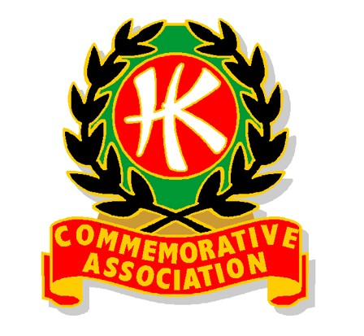
Things happen for a reason
The Tablecloth
The brand new pastor and his wife, newly assigned to their first ministry, to reopen a church in suburban Brooklyn, arrived in early October excited about their opportunities. When they saw their church, it was very run down and needed much work. They set a goal to have everything done in time to have their first service on Christmas Eve.
They worked hard, repairing pews, plastering walls, painting, etc. and on December 18 were ahead of schedule and just about finished.
On December 19 a terrible tempest – a driving rainstorm hit the area and lasted for two days. On the 21st, the pastor went over to the church. His heart sank when he saw that the roof had leaked, causing a large area of plaster about 20’ by 8’ to fall off the front wall of the sanctuary just behind the pulpit, beginning about head high.
The pastor cleaned up the mess on the floor, and not knowing what else to do but postpone the Christmas Eve service, headed home. On the way he noticed that a local business was having a flea market type sale for charity so he stopped in. One of the items was a beautiful, handmade, ivory colored, crocheted Tablecloth with exquisite work, fine colors and a Cross embroidered right in the center. It was just the right size to cover up the hole in the front wall. He bought it and headed back to the church.
By this time it had started to snow. An older woman running from the opposite direction was trying to catch the bus… She missed it. The pastor invited her to wait in the warm church for the next bus 45 minutes later. She sat in a pew and paid no attention to the pastor while he got a ladder, hangers, etc., to put up the Tablecloth as a wall tapestry. The pastor could hardly believe how beautiful it looked and it covered up the entire problem area.
Then he noticed the woman walking down the center aisle. Her face was like a sheet…”Pastor”, she asked, “where did you get that Tablecloth?”. The pastor explained. The woman asked him to check the lower right corner to see if the initials, EBG were crocheted into it there. They were. These were the initials of the woman, and she had made this Tablecloth 35 years before, in Austria.
The woman could hardly believe it as the pastor told how he had just gotten the Tablecloth. The woman explained that before the war she and her husband were well-to-do people in Austria. When the Nazis came, she was forced to leave. Her husband was going to follow her the next week. He was captured, sent to prison and never saw her husband or her home again.
The pastor wanted to give her the Tablecloth; but she made the pastor keep it for the church. The pastor insisted on driving her home, that was the least he could do. She lived on the other side of Staten Island and was only in Brooklyn for the day for a housecleaning job.
What a wonderful service they had on Christmas Eve. The church was almost full. The music and the spirit were great. At the end of the service, the pastor and his wife greeted everyone at the door and many said that they would return.
One older man, whom the pastor recognized from the neighbourhood continued to sit in one of the pews and stare, and the pastor wondered why he wasn’t leaving.
The man asked him where he got the Tablecloth on the front wall because it was identical to one that his wife had made years ago when they lived in Austria before the war and how could there be two Tablecloths so much alike.
He told the pastor how the Nazis came, how he forced his wife to flee for her safety and he was supposed to follow her, but he was arrested and put in a prison. He never saw his wife or his home again all the 35 years in between.
The pastor asked him if he would allow him to take him for a little ride. They drove to Staten Island and to the same house where the pastor had taken the woman three days earlier.
He helped the man climb the three flights of stairs to the woman’s apartment, knocked on the door and he saw the greatest Christmas reunion he could ever imagine.
Who says God does not work in mysterious ways.
A true Story
Merry Christmas to you and yours from your BOD
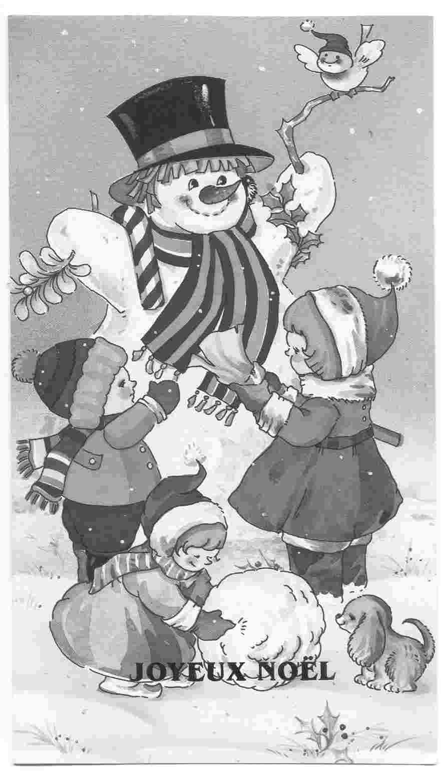
Take care,
Till next time – March 2006.
Lucette

